**IDA Pro Analysis**

Grand Canyon University - College of Engineering and Technology

CYB-320 Malware Analysis

Dr. Michael Varnadore

Liela Pressley

09/29/2024

**IDA Pro Analysis**

1. **What is the address of DLLMain?**
   1. DLLMain is a placeholder for an entry point into a Dynamic Link Library (DLL). When a system starts or terminates a process it will call the entry point function for each DLL that is being loaded using the first thread of the process. It is also called when it is loaded or unloaded using the LoadLibrary and FreeLibrary functions.
   2. 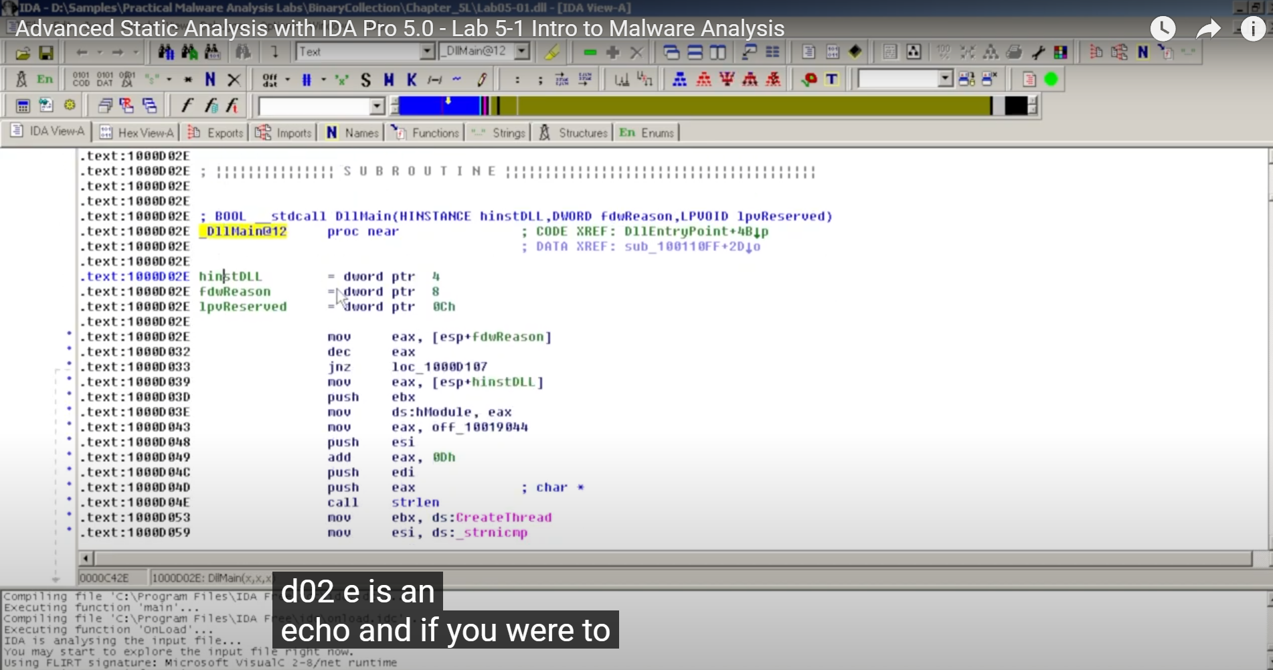
   3. For this lab the DLL Main address is: **1000D 02E**
2. **Where is the string \cmd.exe /c within the disassembly?**
   1. You can do a search substring to locate where the string is in the disassembly… The string \cmd.exe /c is located at xdoors_d:10095B344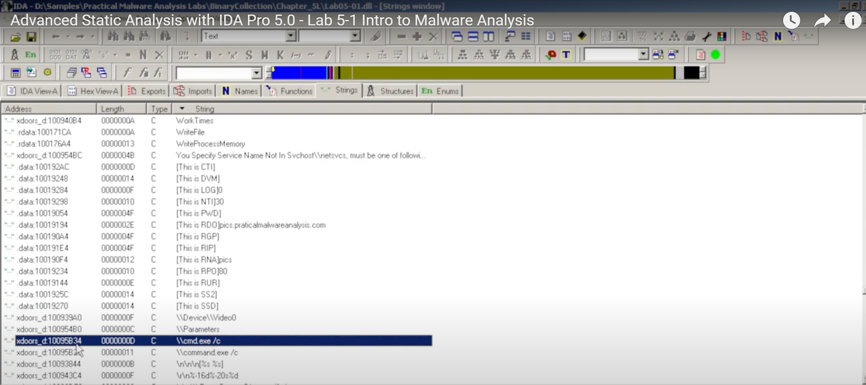
3. **What is happening in the area of code that references \cmd.exe /c?**
   1. It checks if the OS target is Windows 2000 or less if it is then it will execute the command.exe if it does not then it will execute cmd.exe. Then there are other strings that look like commands such as: quit, exit, cmd, enmagic, idle, uptime, language, etc.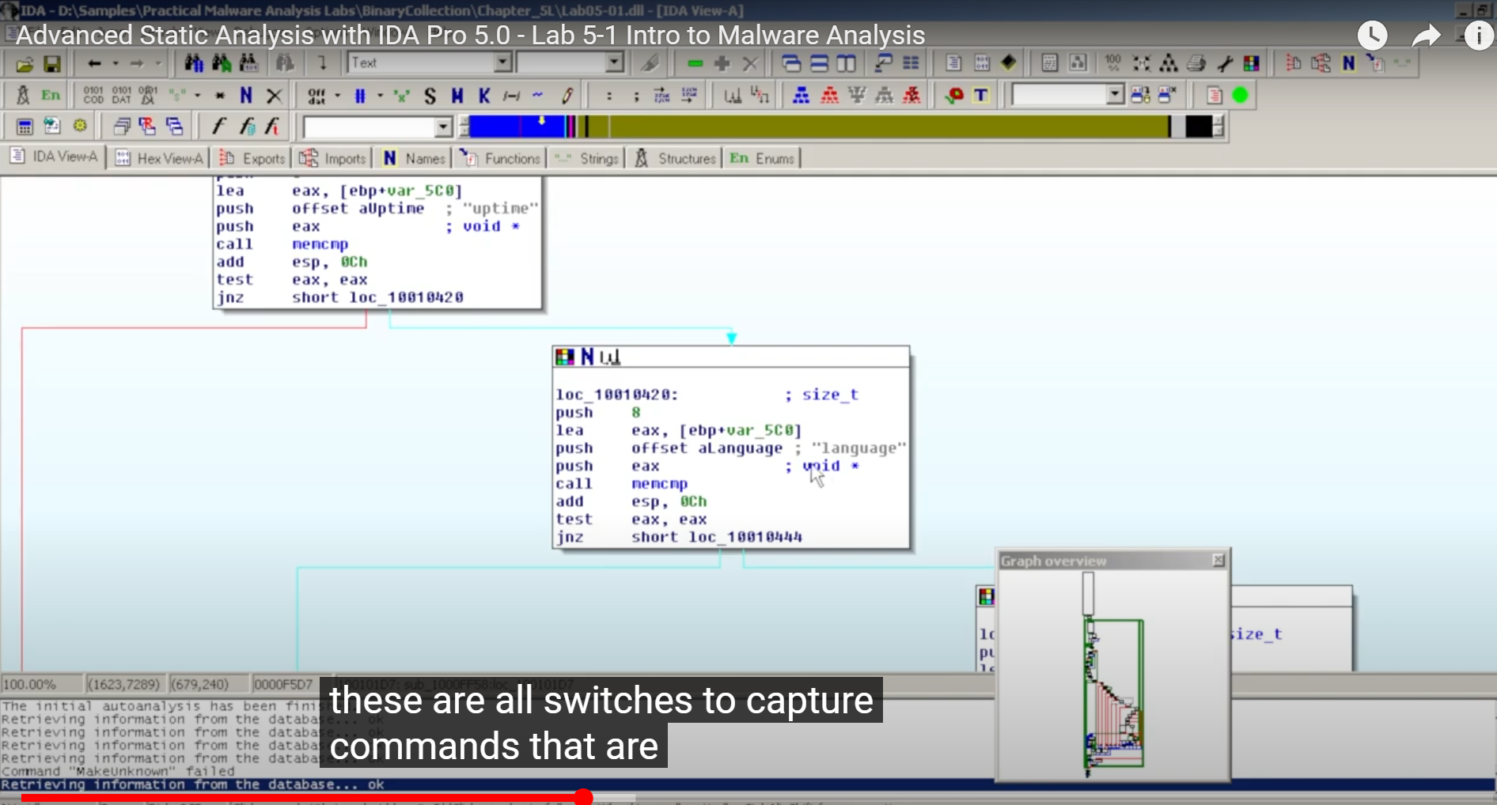
4. **Looking at the call to gethostbyname located at 0x10001757, can you figure out which DNS request will be made?**
   1. 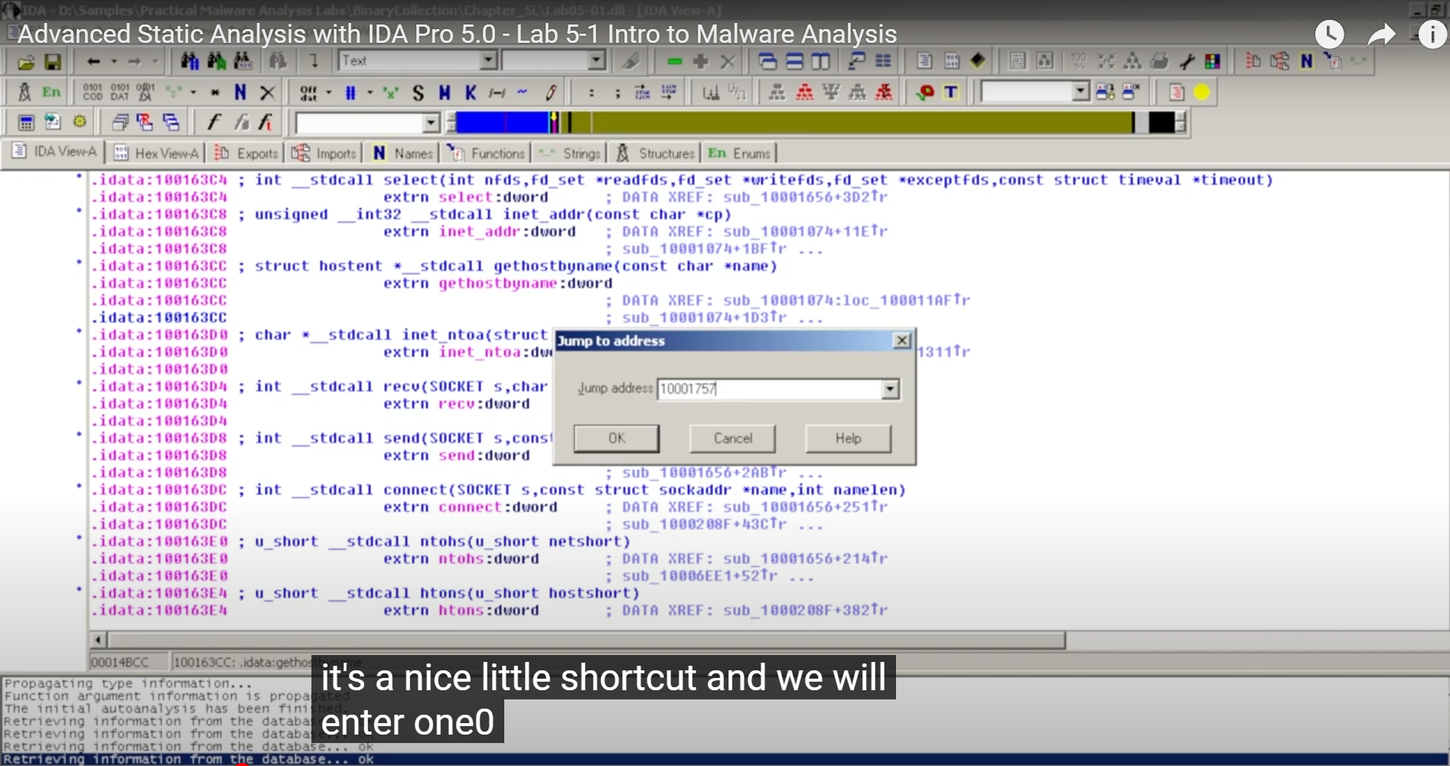
   2. 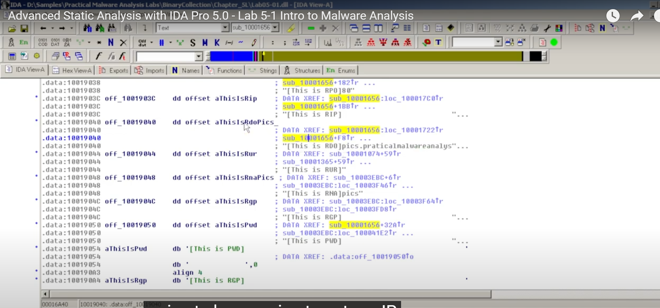
   3. A DNS query is being made to look for the IP address associated with the string: “[This is RDO]pic.practicalmalwareanalysis.com’,0
5. **Provide an analysis of the malware's functionality.**
   1. There are over 20 local variables for the subroutine at 0x10001656.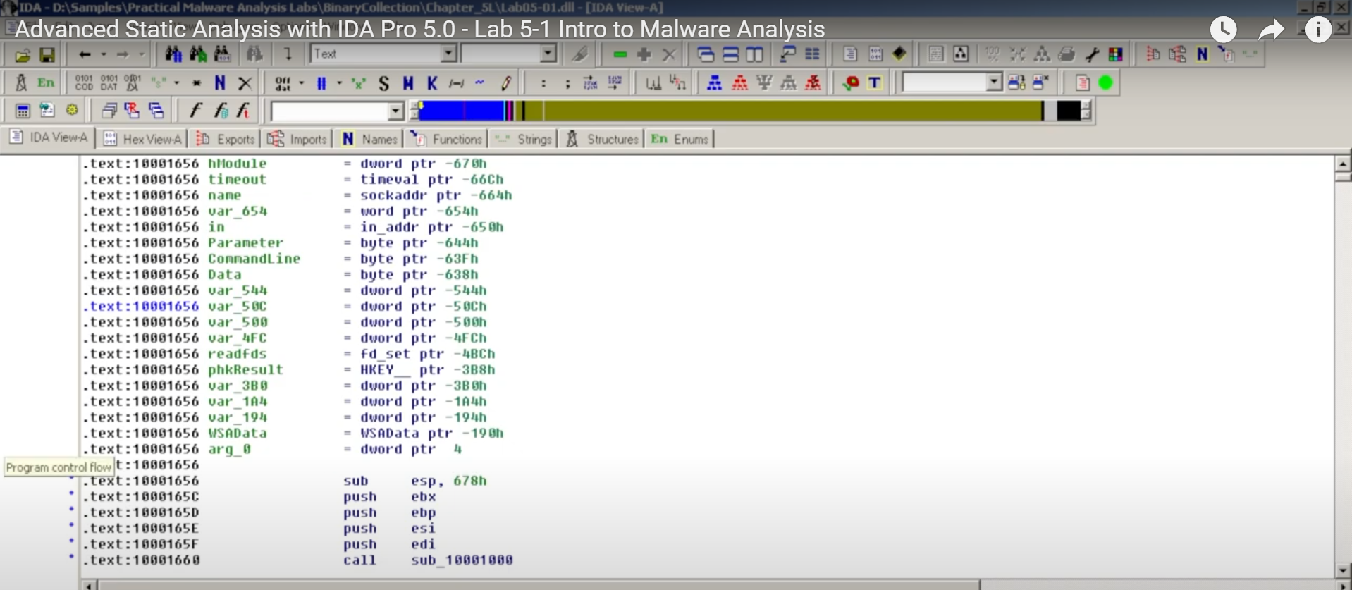
   2. Contained odd strings within the machine uptime portion. Revealed that is is a Remote Shell Application. 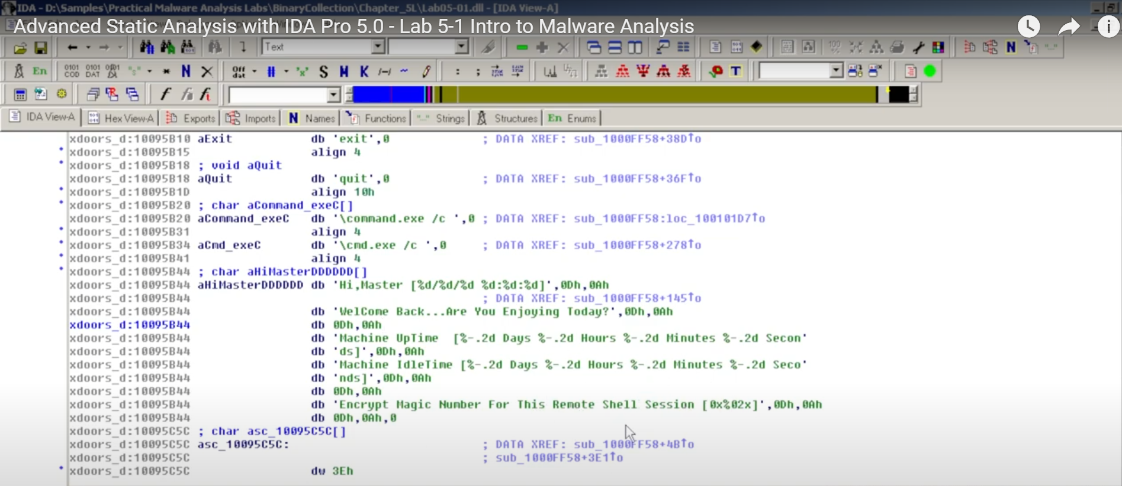
   3. 10003695is set at eax registry then is moved to dword_1008E5C4 and determines what version of OS or more specifically what version of Windows is running.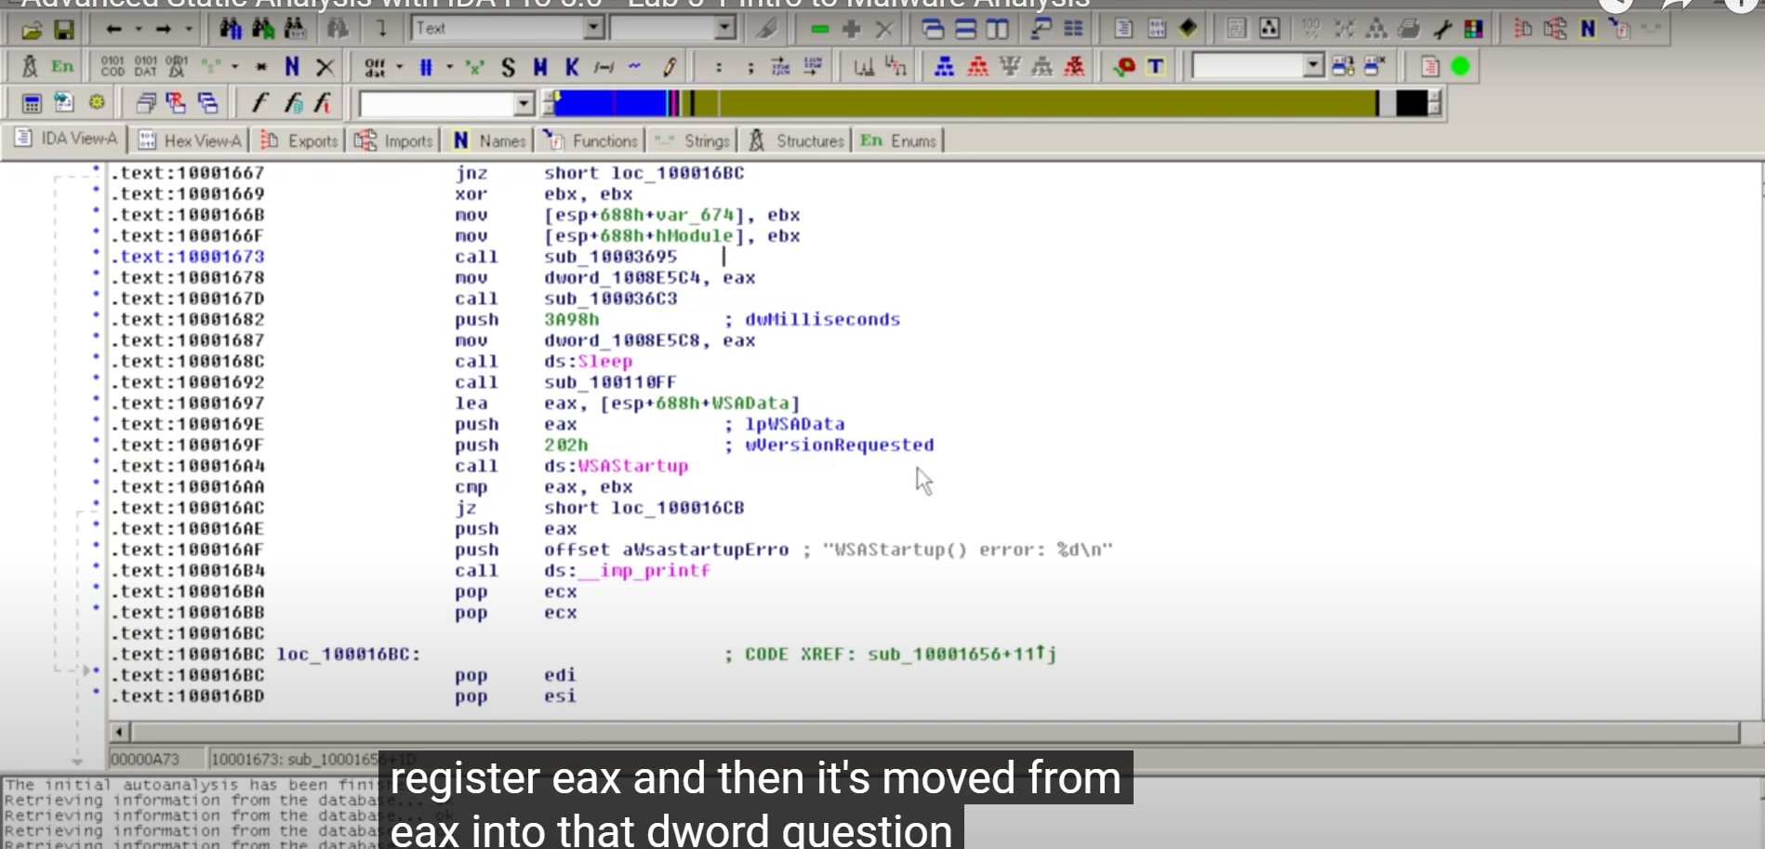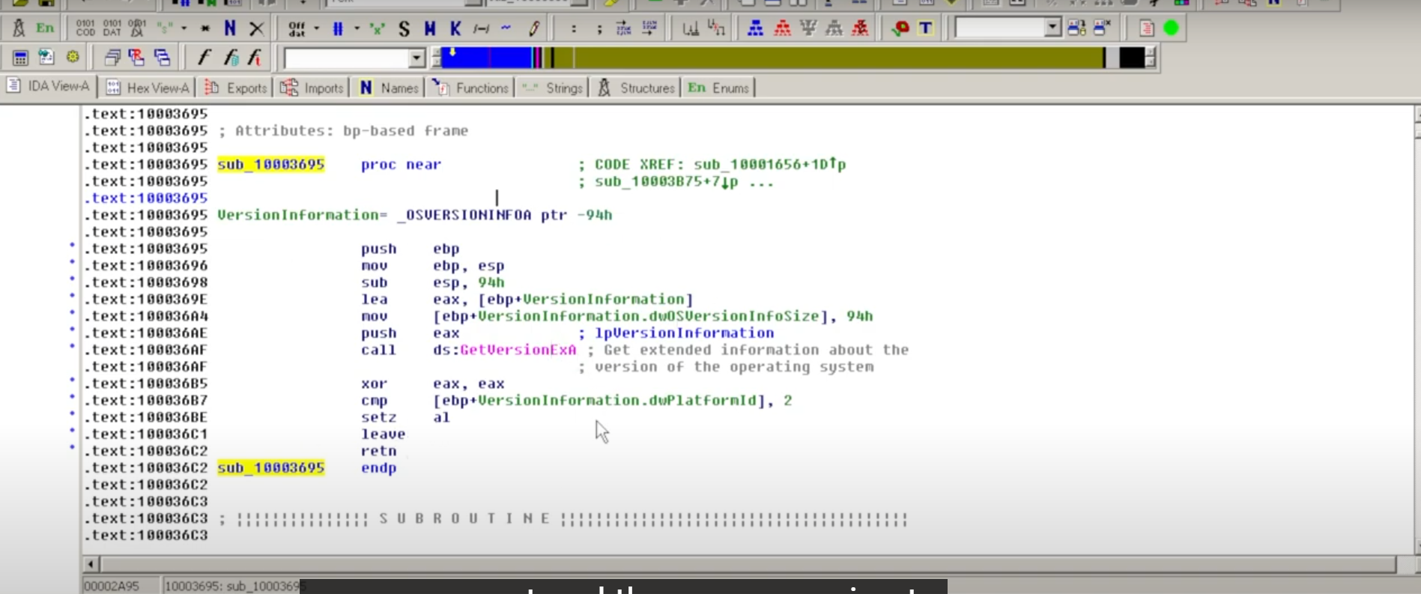
6. **What are several useful malware disassemblers and debugging analysis tools? Support your answer with evidence.**
   1. IDA Pro is a great disassemble and reverse engineering tool which is compatible with various platforms and processors and allows for beginner and expert analysts to perform function discovery, stack analysis, local variable identification and reference a code signature database.
   2. GHIDRA is a reverse engineering framework that was developed by NSA which provides tools to analyze compiled code and is an open-sourced tool. It is considered faster and more efficient than IDA Pro when analyzing multiple binaries.
   3. Debuggers provide information about a program that are not easily accessible from a disassembler as they provide a dynamic view of the running program. WinDbg is a great tool that supports kernel debugging along whereas, OllyDbg is a well used debugging tool that doesn’t support kernel debugging.
7. **What reverse engineering tools and techniques (to include software specification recovery and communications protocols) are available for malware analysis? Support your rationale with evidence.**
   1. Reverse engineering tools include IDA pro as it allows you to change the elements of displayed data such as names, data representation, build diagrams and flow graphs, recognize standard library functions,etc.
   2. CFF Explorer is a suite of tools for portable executable with import editing, address converting, dependency analyzing, signature scanning, a resource editor and more.
   3. API Monitor is an application that intercepts API function calls made by apps and services while displaying data inputs and outputs.
8. **What are the advantages and weaknesses of reverse engineering techniques? Support your answer with evidence**
   1. Reverse engineering is extremely useful for malware analysts as it allows professionals in a company to replicate the potential malware events and research without external research and development costs. It also allows for analysts to see an inside look at how the malware was successful and broadens the scope to all that the malware was intended to do and did accomplish. In addition it allows for companies to to identify areas that can be improved to create better products internally and to create a proactive security plan.
   2. Unfortunately, reverse engineering sometimes can’t provide a 100% detailed explanation to the malware’s purpose as some details may be mislabeled (by the author) to divert the true intention or action the malware is performing. There is also a lot of code that needs to be sifted through which makes the task very time consuming or can risk the process to not capture necessary information that can be hidden or overlooked.

**References**

Aid. (2024, May 20). *9 Best Reverse Engineering Tools for 2024 [Updated]*. Apriorit. https://apriorit.com/dev-blog/366-software-reverse-engineering-tools

David K. (2024, February 26). *Advanced Static Analysis with IDA Pro 5.0 - Lab 5-1 Intro to Malware Analysis* [Video]. YouTube. https://www.youtube.com/watch?v=dBGwa13vBXs

Progsky. (2024, June 7). GHIDRA VS IDA PRO: a COMPARISON OF TWO POPULAR REVERSE ENGINEERING TOOLS. *Medium*. https://medium.com/@Progsky/ghidra-vs-ida-pro-a-comparison-of-two-popular-reverse-engineering-tools-55223fad9193#:~:text=Both%20Ghidra%20and%20IDA%20Pro%20have%20similar%20performance%20when%20it,have%20some%20differences%2C%20such%20as%3A&text=Ghidra%20is%20faster%20and%20more,threading%20features%20of%20the%20CPU.

Stevewhims. (2022, September 2). *DllMain entry point (Process.h) - Win32 apps*. Microsoft Learn. https://learn.microsoft.com/en-us/windows/win32/dlls/dllmain

*The Advantages And Disadvantages Of Reverse Engineering*. (n.d.). fastercapital.com. https://fastercapital.com/topics/the-advantages-and-disadvantages-of-reverse-engineering.html#:~:text=Time%2DConsuming%3A%20Reverse%20engineering%20can,processes%20are%20proprietary%20or%20confidential.

*Top 15 tools for malware analysis and reversal | Infosec*. (n.d.). https://www.infosecinstitute.com/resources/malware-analysis/malware-analysis-arsenal-top-15-tools/